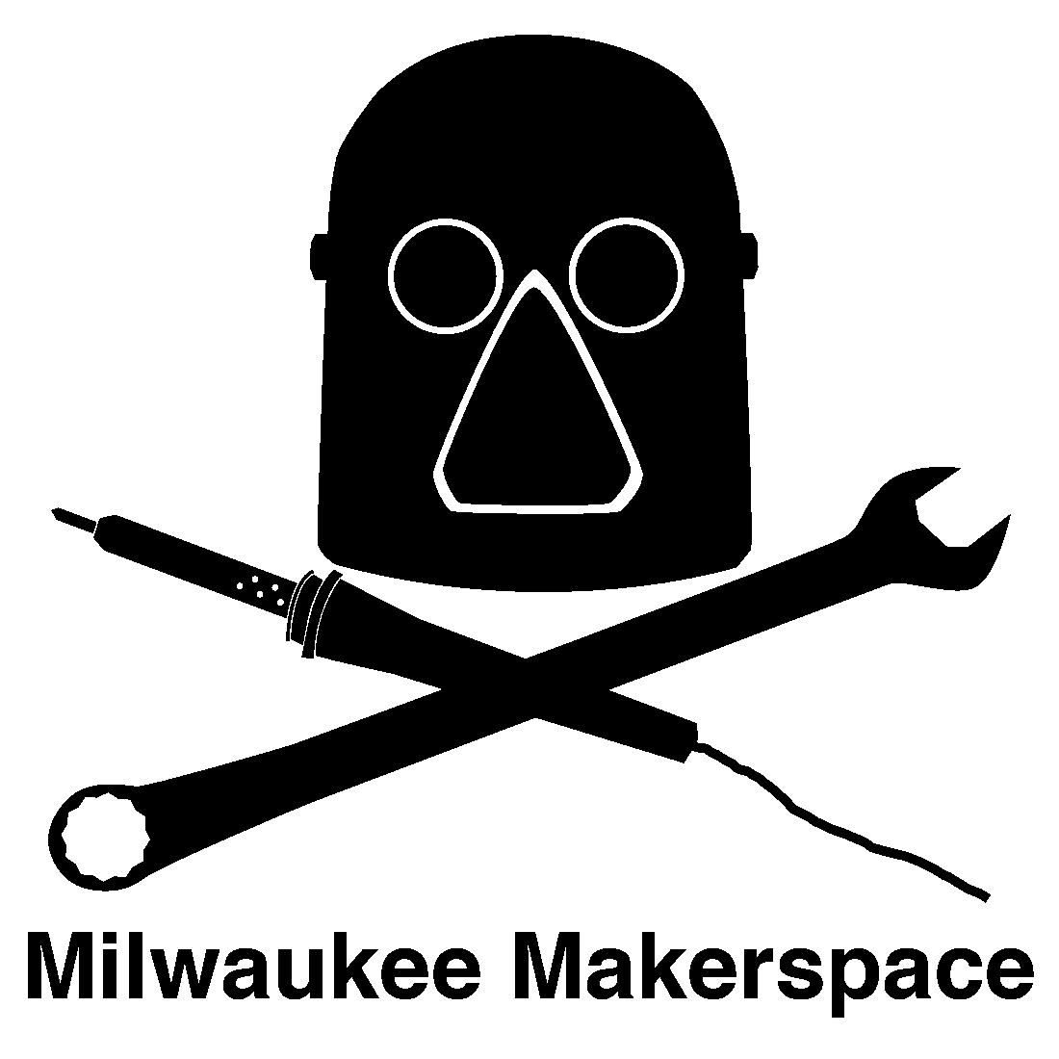
Monthly Orientation Class

Purpose of this class:
- Familiarize
- Prepare
- Educate
- Introduce
Things you’ll learn about:
- Our Group
- Our Building
- Policies & Procedures
- Equipment & Safety
- Meetings & Events
- Our Culture
Tom’s Garage – September 2009
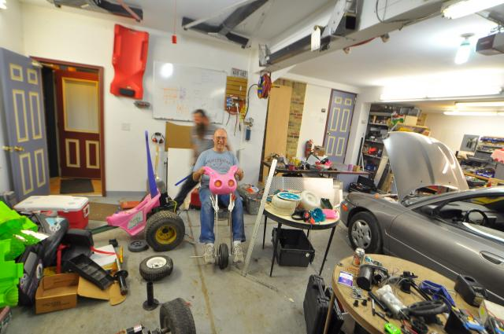

Our First Building – November 2010

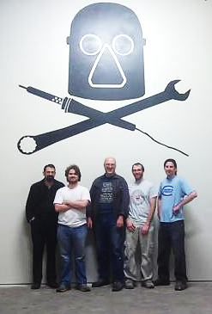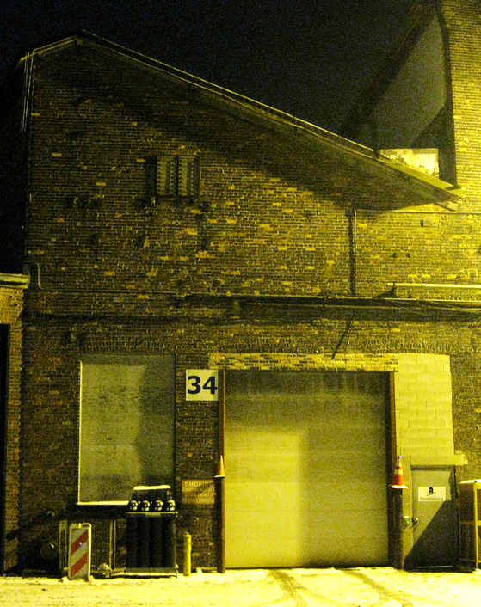
Grand Opening – April 2011
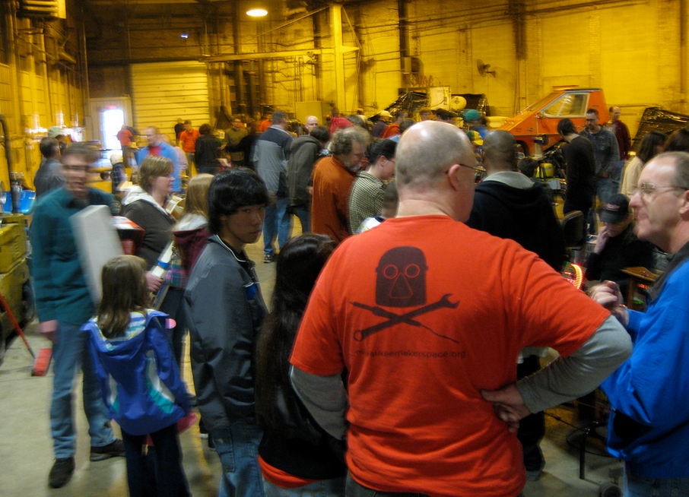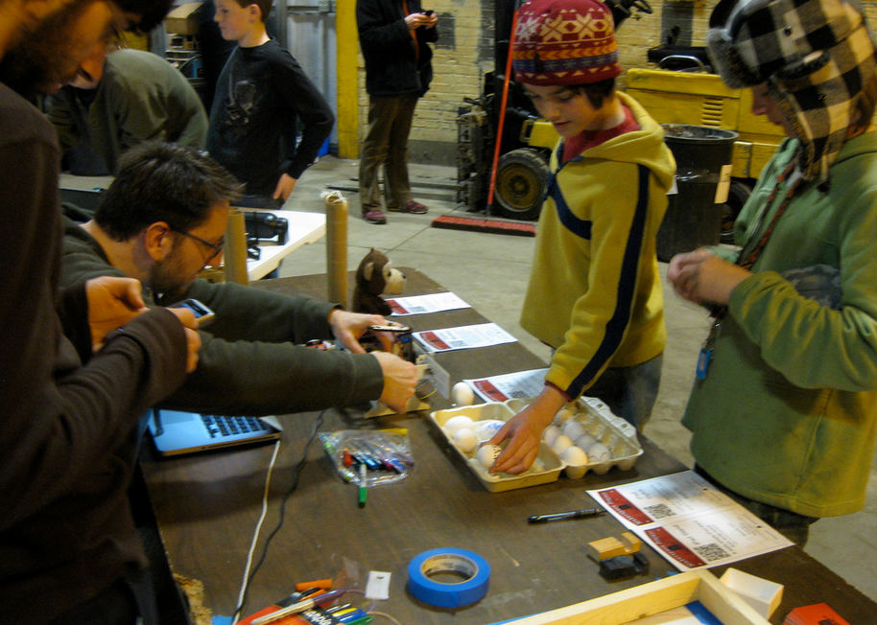
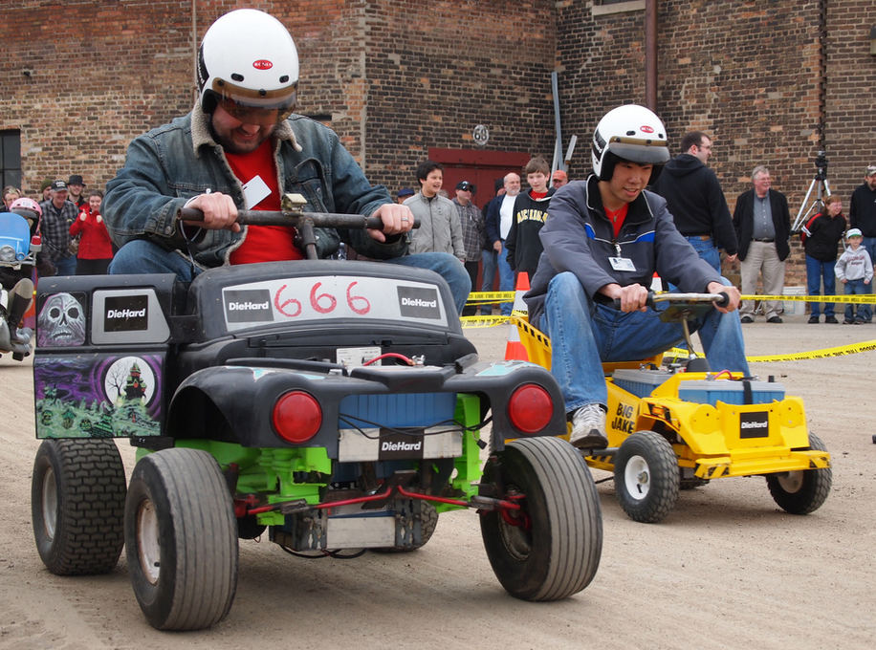
First Board – October 2012
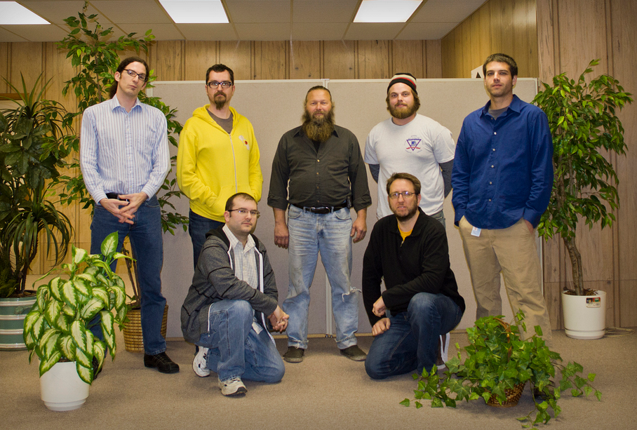

Move to Lenox – January 2013
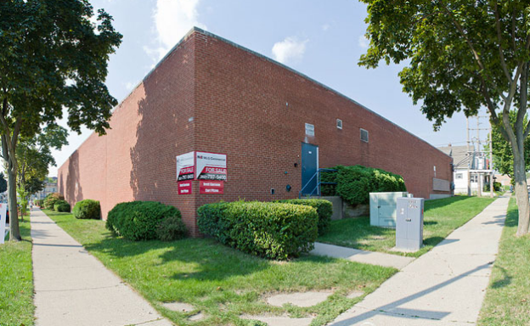
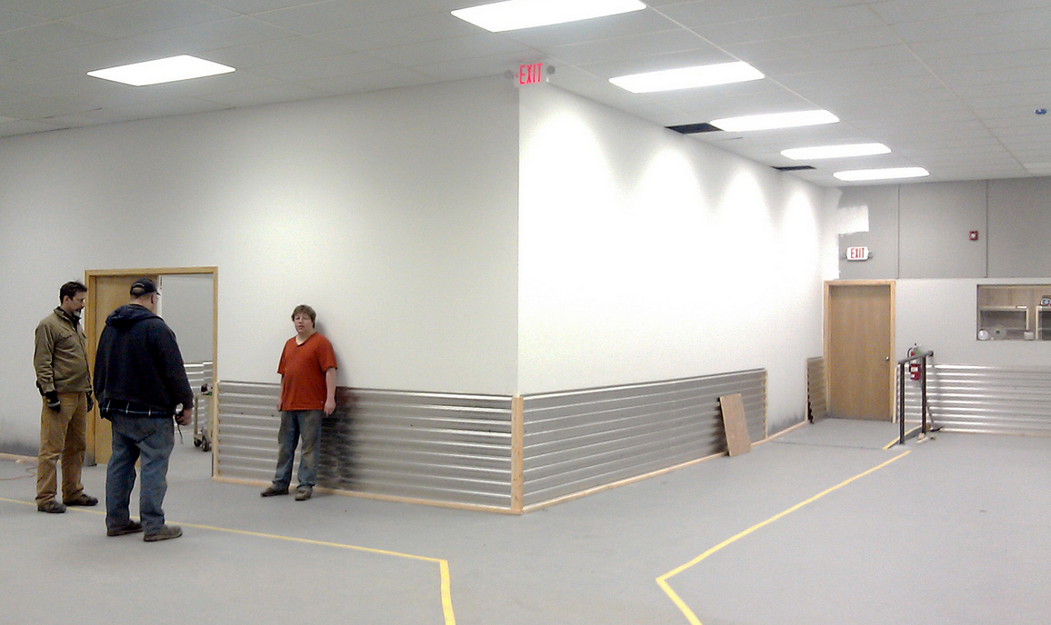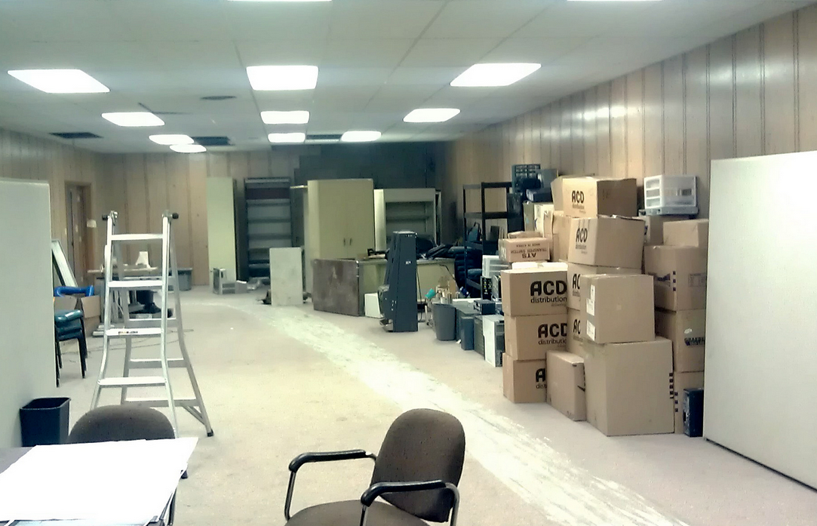
100 members – July 2013
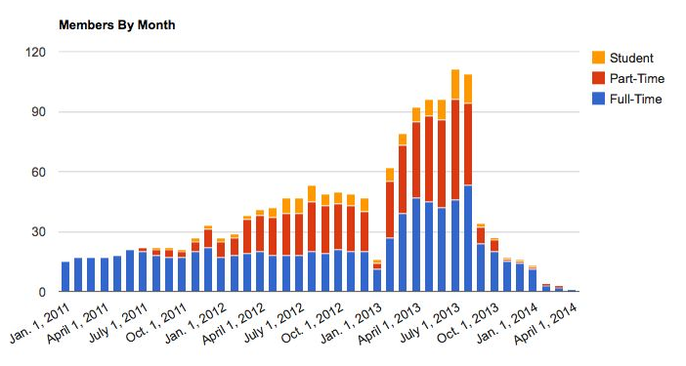

Makerfest – October 2013
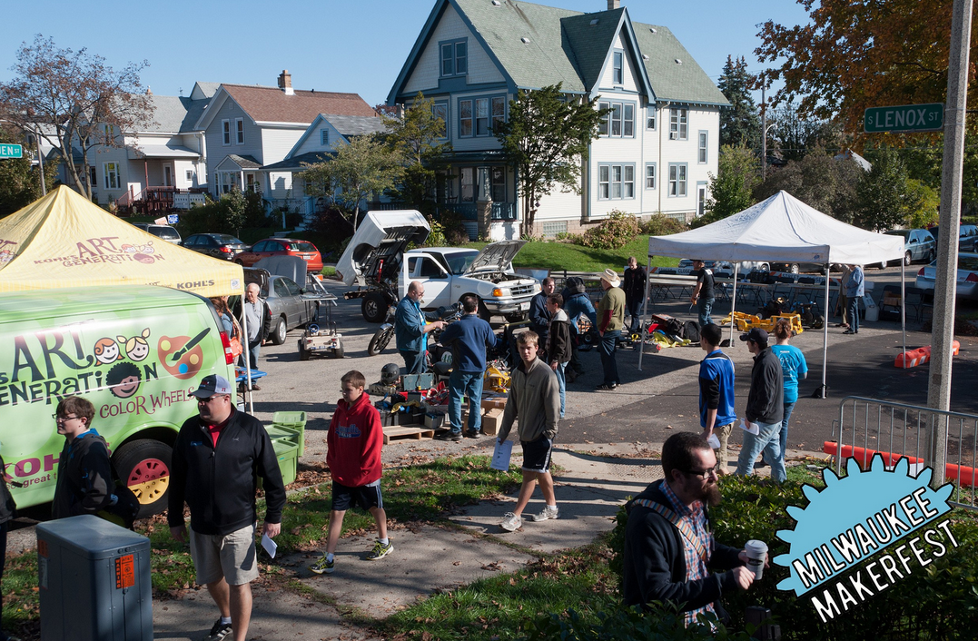

Today

Our Building

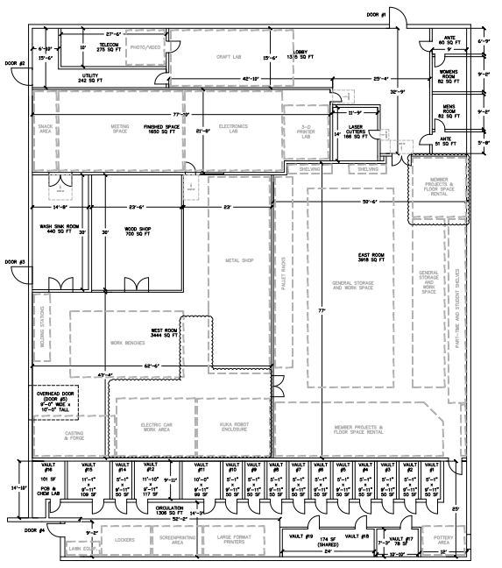Spaces
Exits
Parking
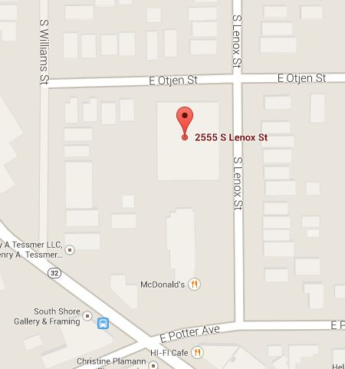
Parking
Lighting in most rooms
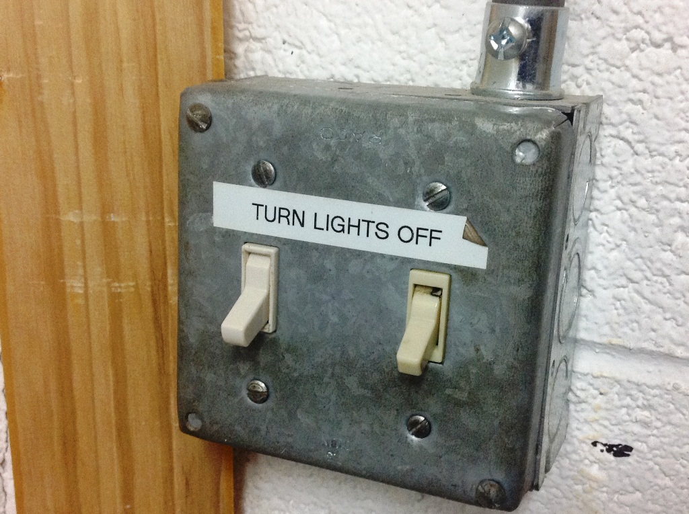
Workshop Lights!
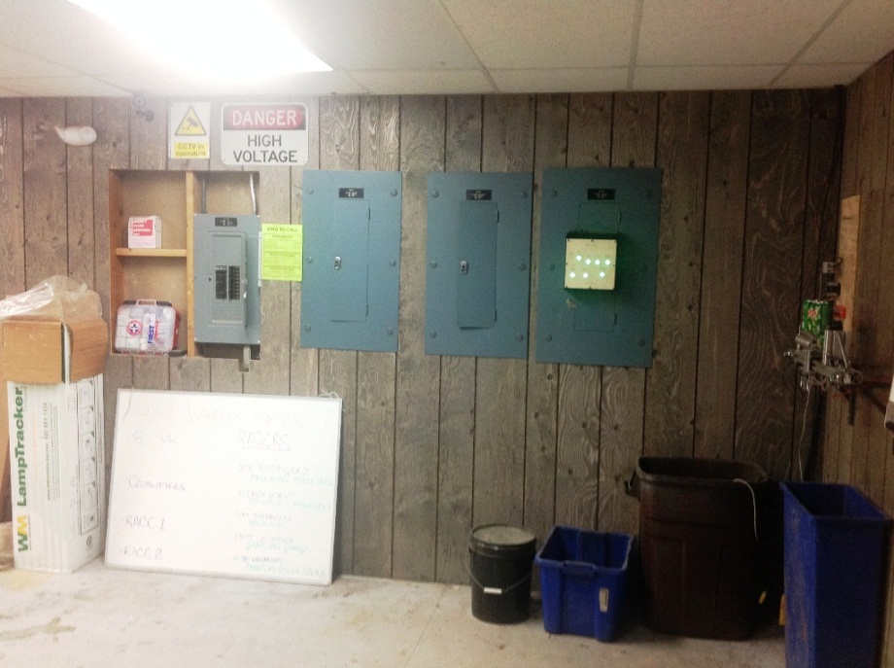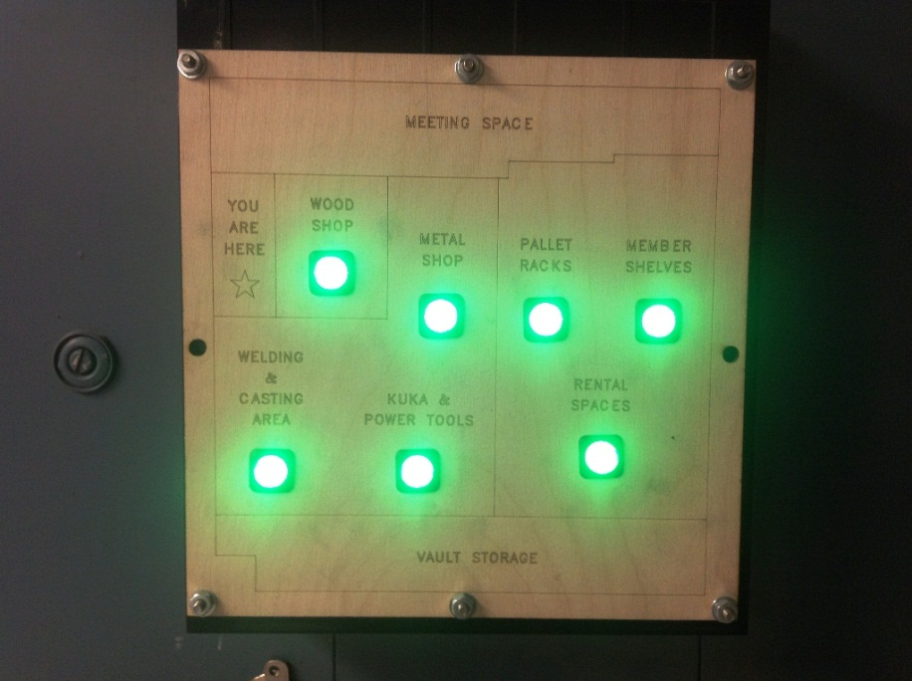

Heating & Air Conditioning!
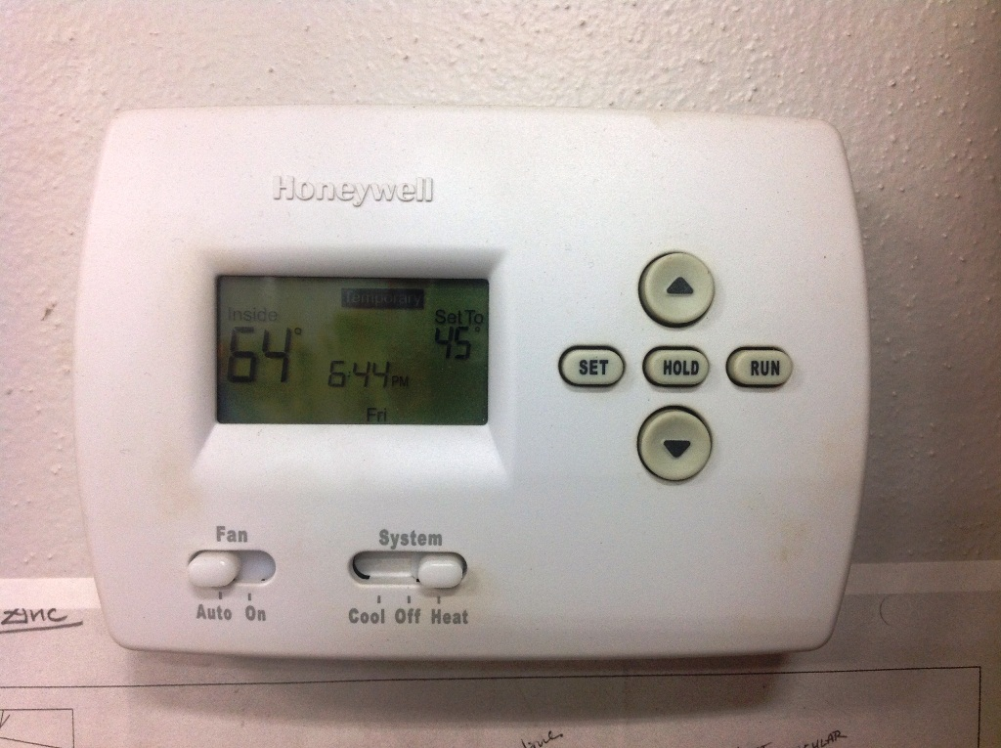
Internet!
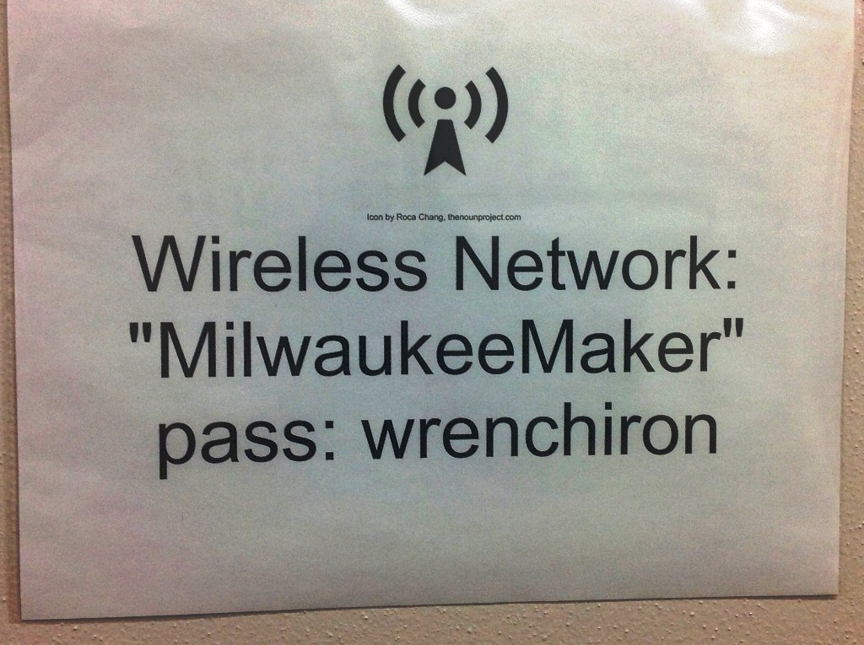
Paper Goods &
Cleaning Supplies!
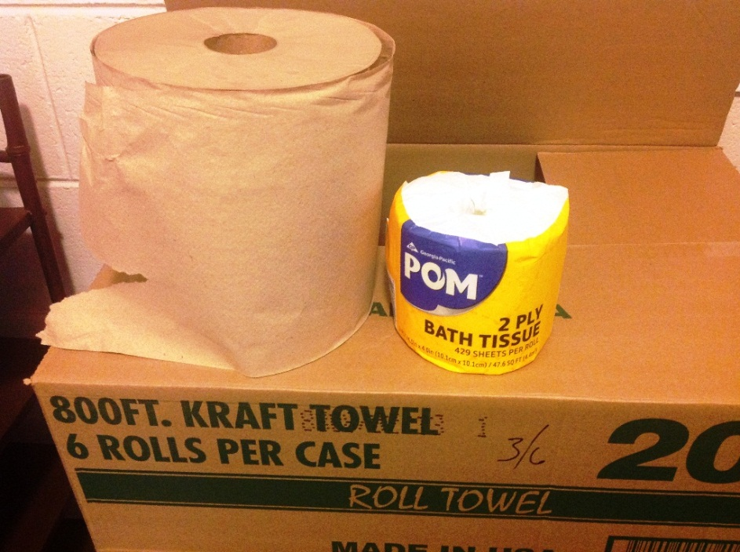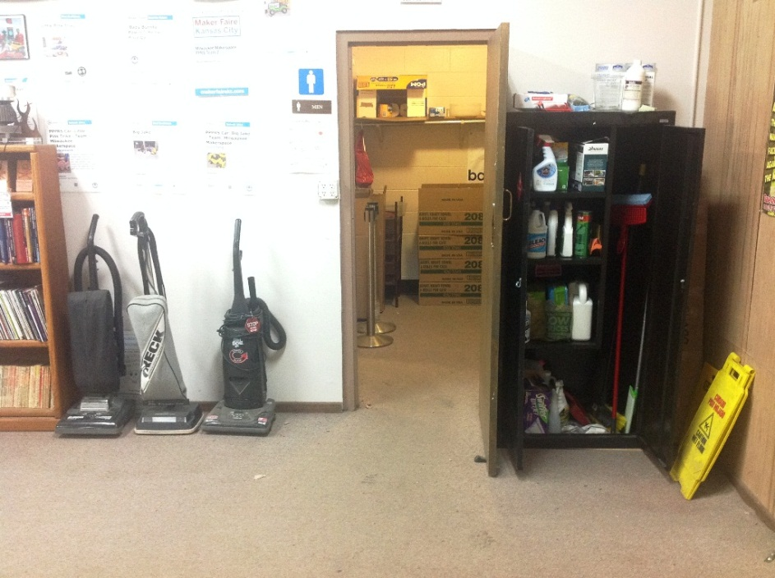

Soda & Beer in fridges!

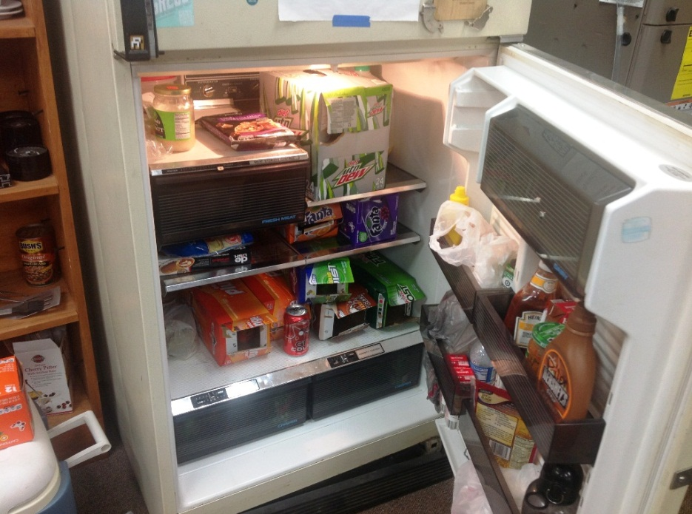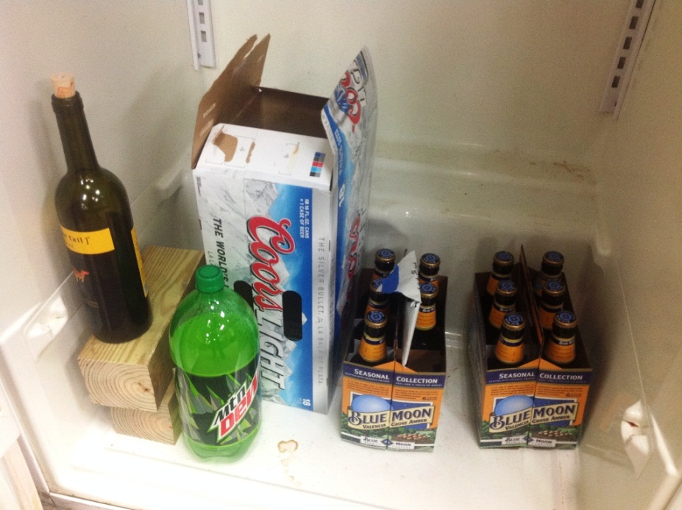

Trash disposal!
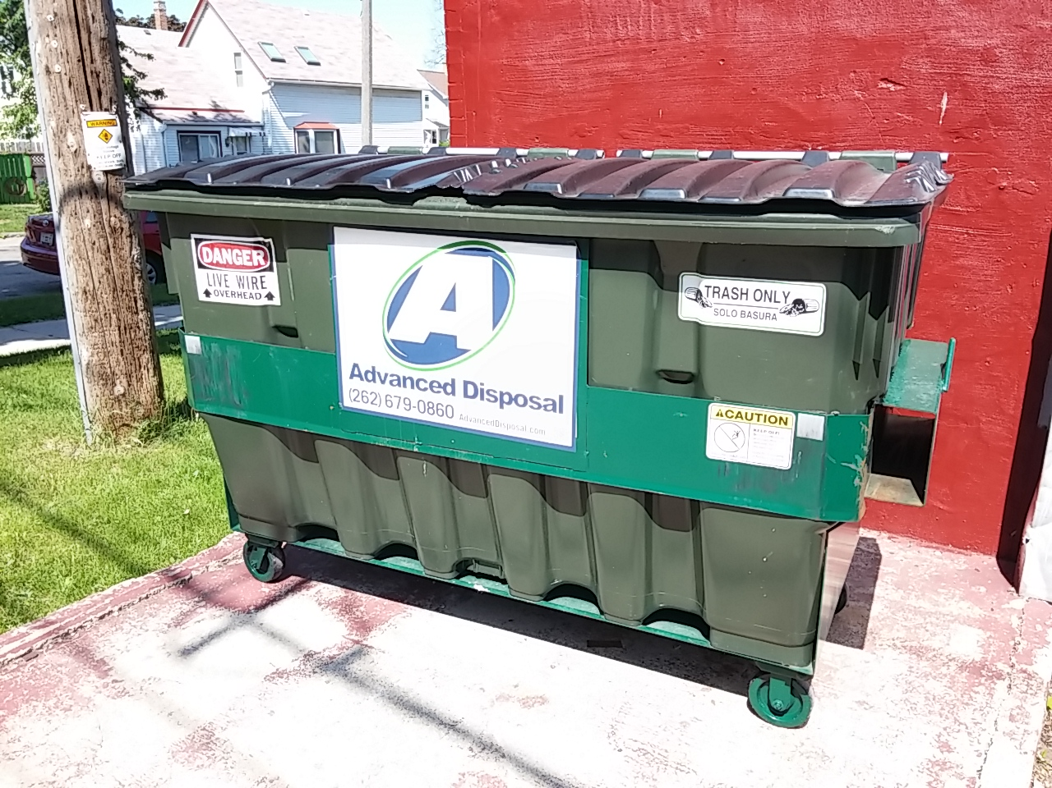

Policies & Procedures

Member Handbook on the wiki
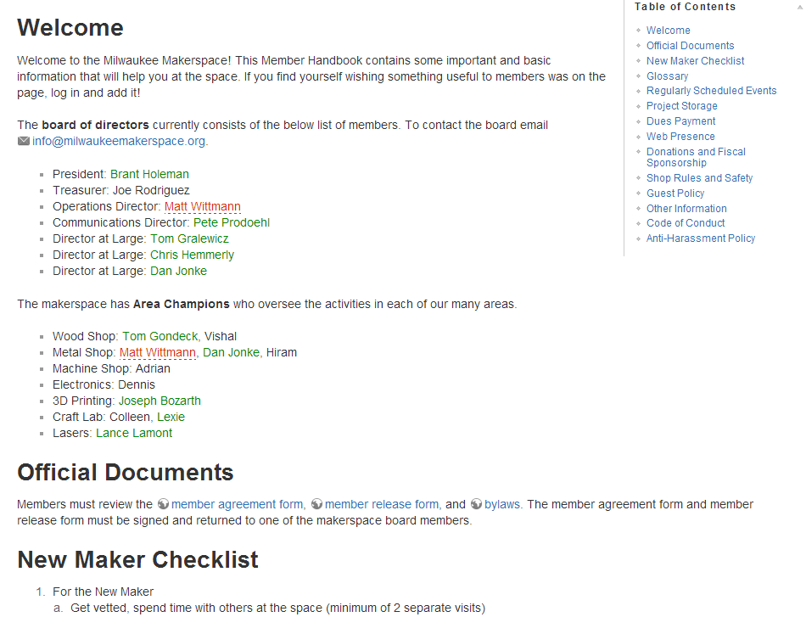

Our By-Laws on the website
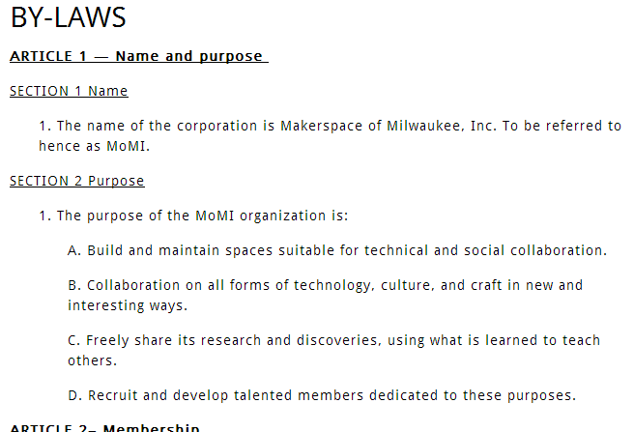

Our Board of Directors

- President
- Treasurer
- Communications Director
- Operations Director
- (3) “At-Large” Board Members

Current Board Members
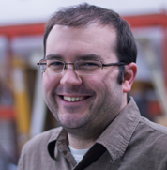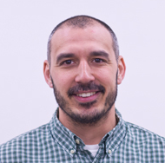
Brant H. Pete P. Joe R. Tiffany M.
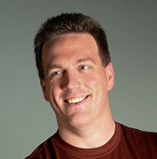
Dan J. Chris H. Tom G.

Current Area Champions

- Wood Shop: Tom Gondek, Vishal
- Metal Shop: Dan Jonke, Hiram
- Machine Shop: Adrian
- Electronics: Dennis
- 3D Printing: Joseph Bozarth
- Craft Lab: Colleen, Lexie
- Lasers: Lance Lamont
- Screen Printing: Pete Prodoehl
- Kuka/Robot room: Matthew Neesley

Tool Use & Training
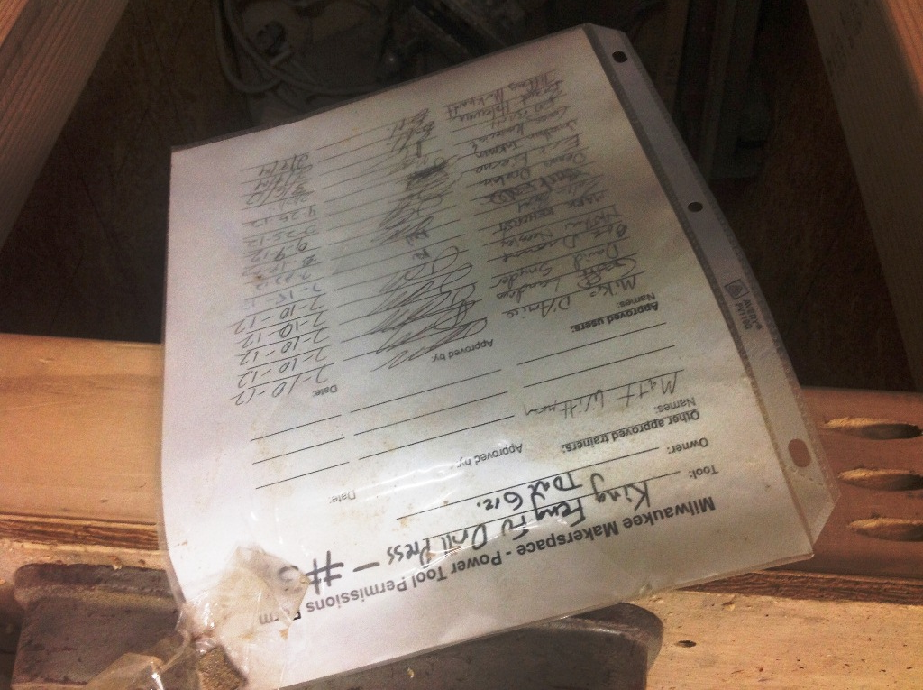
Parking Permits/Tickets
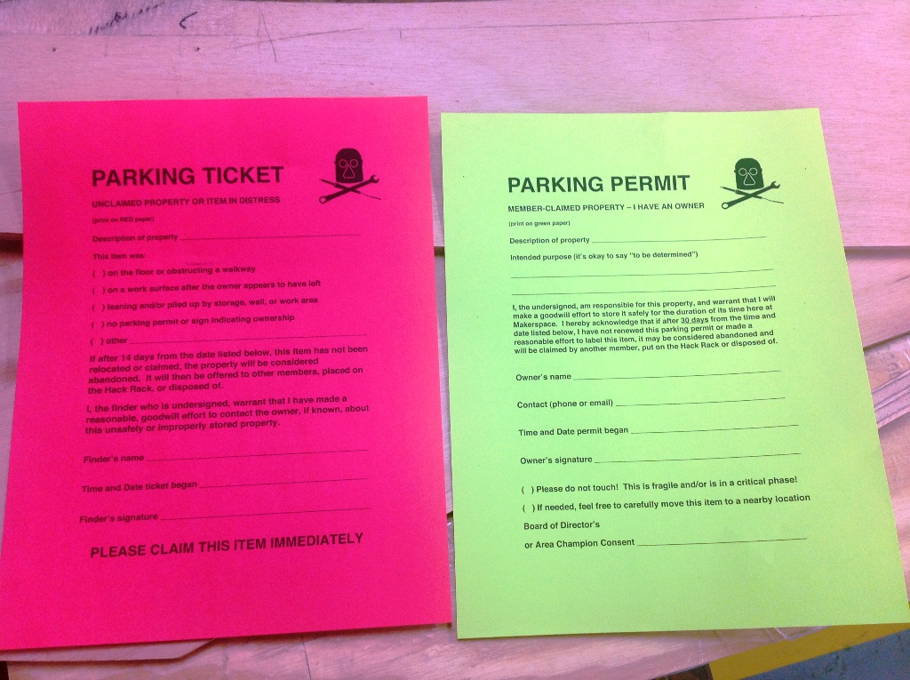
Parking Permits/Tickets
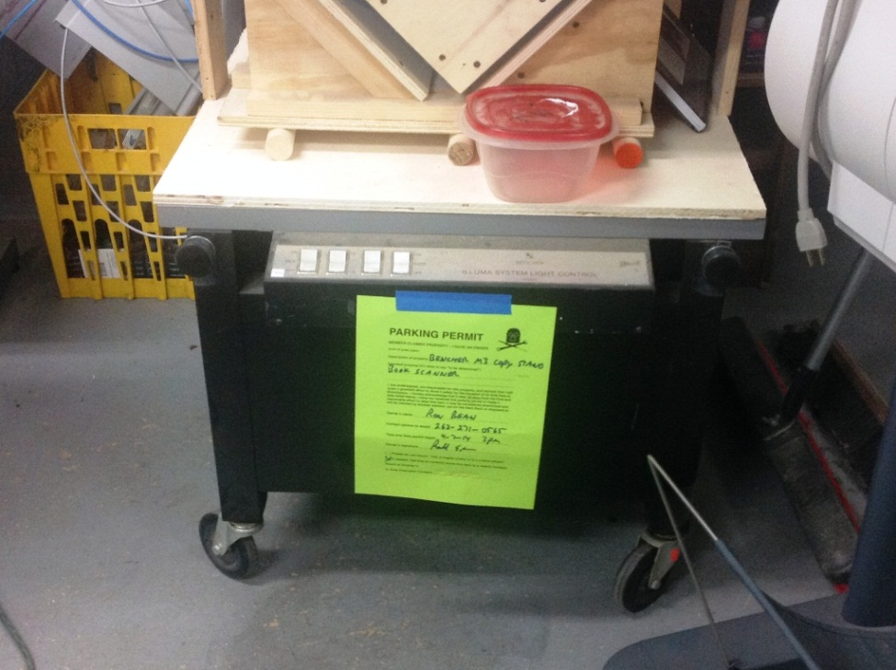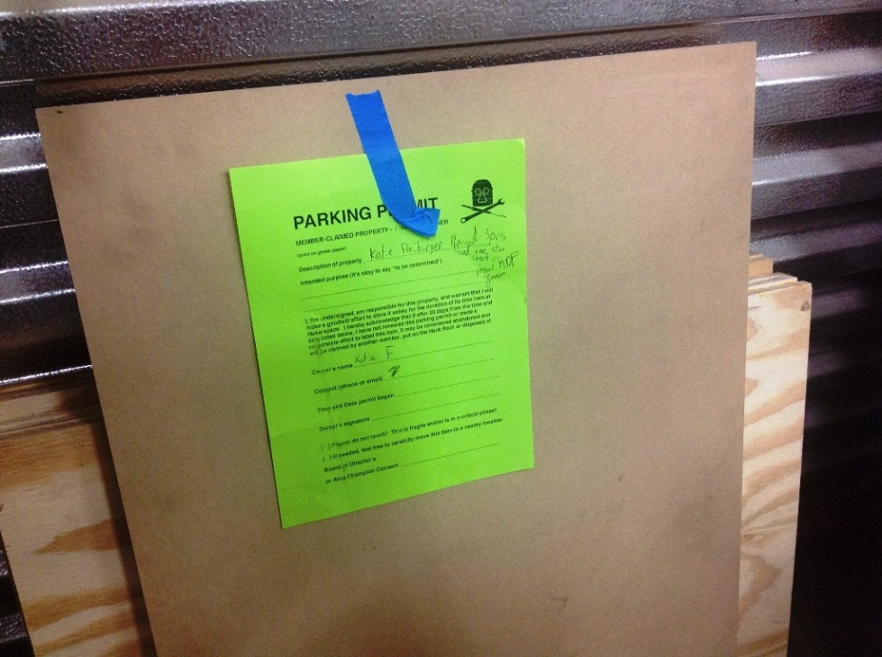

Personal Storage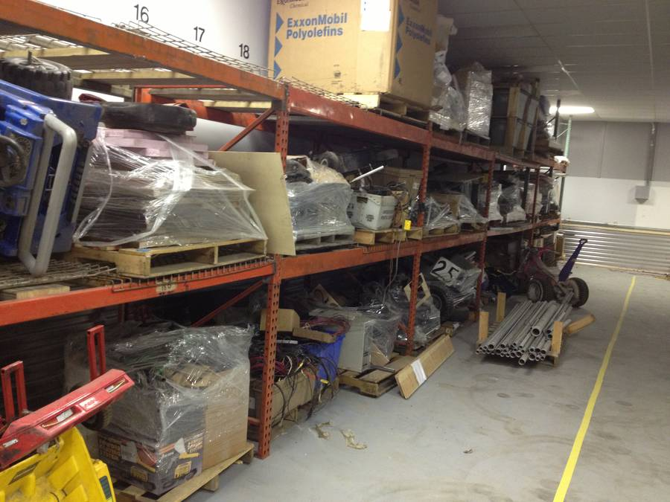
Materials, Parts & The Hack Rack

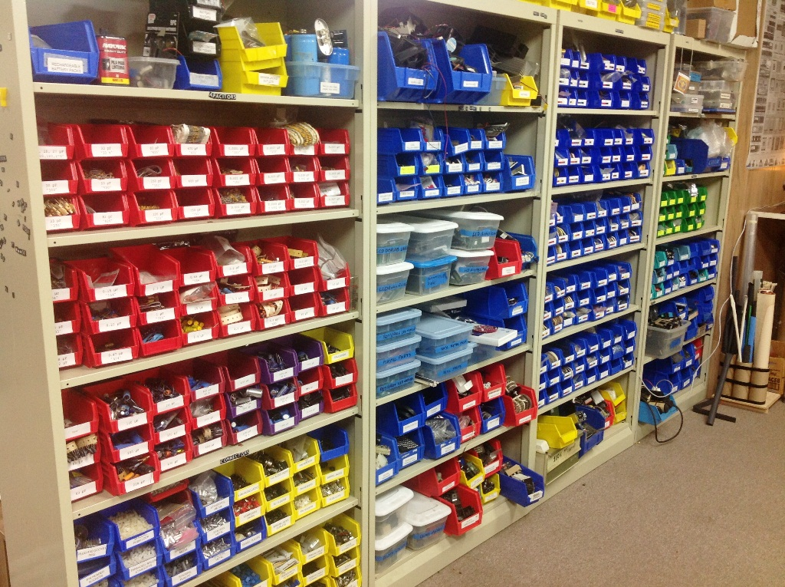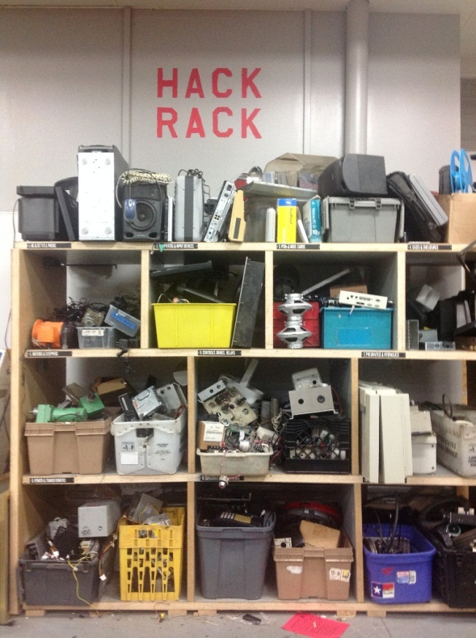

Guests, Children, Pets, Etc.

Donations and Non-Profit Status
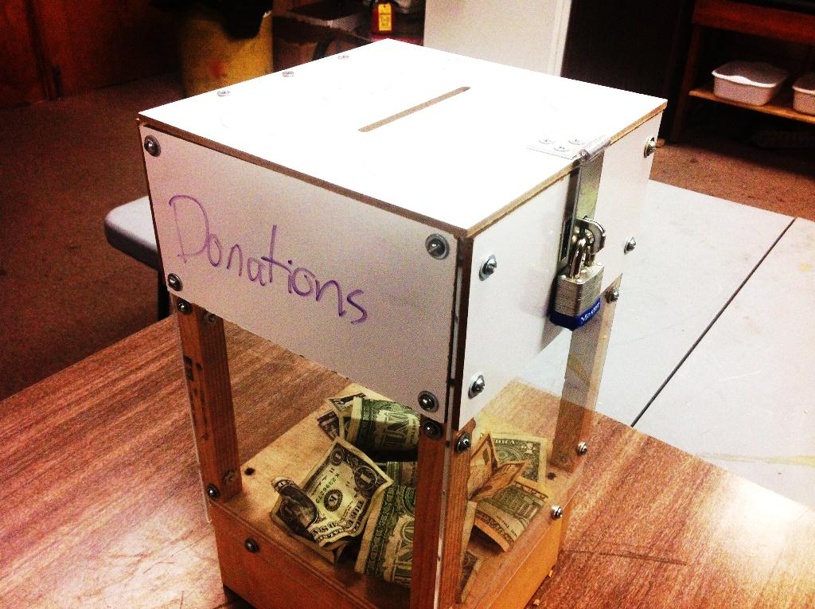

Dues and Rental Payments
Cash, Check, Paypal, Dwolla, Square
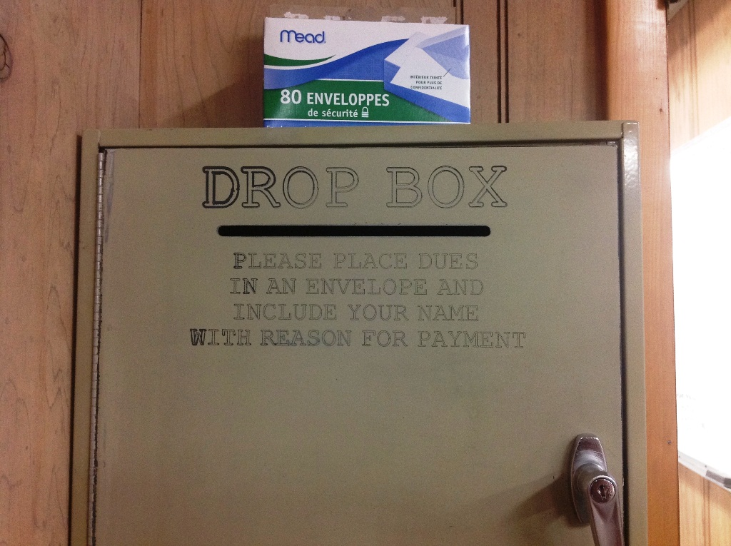

Equipment & Safety

What is your skill level?
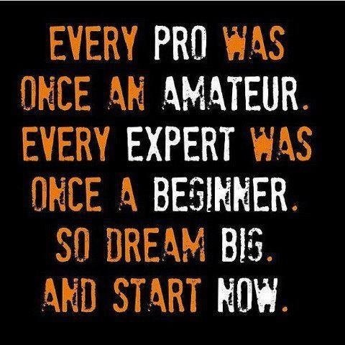
Types of hazards
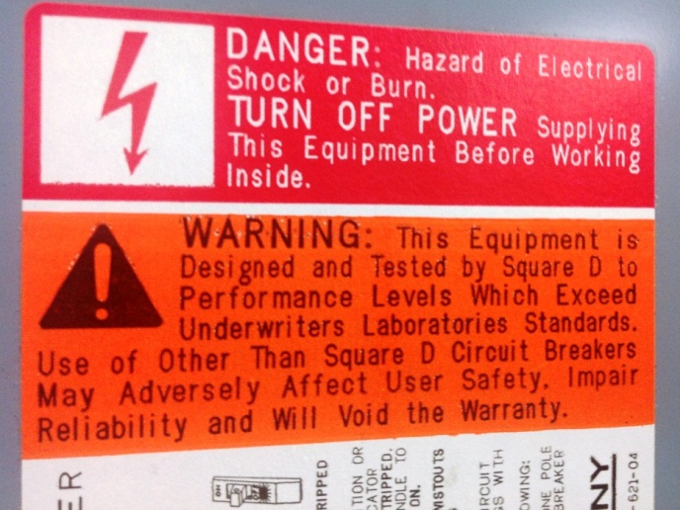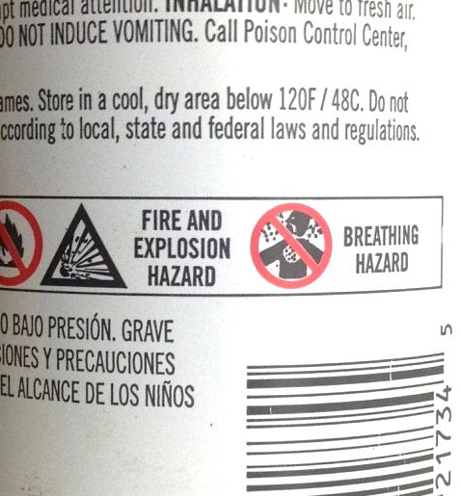
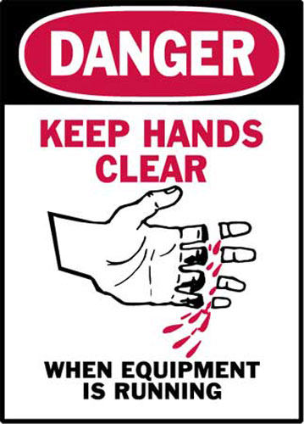
PPE = Personal Protective Equipment
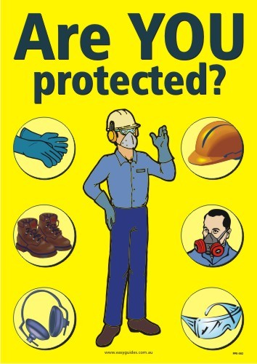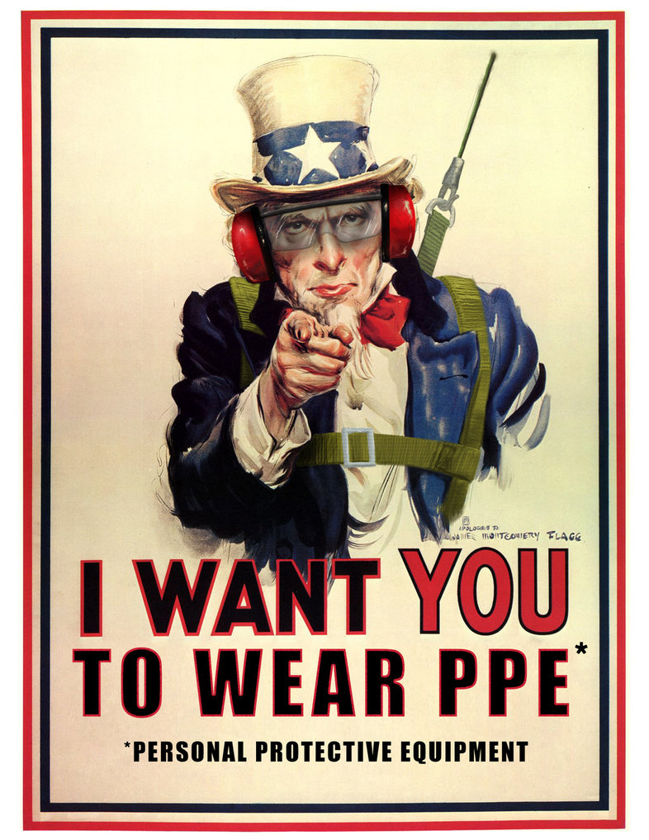
Where to find PPE
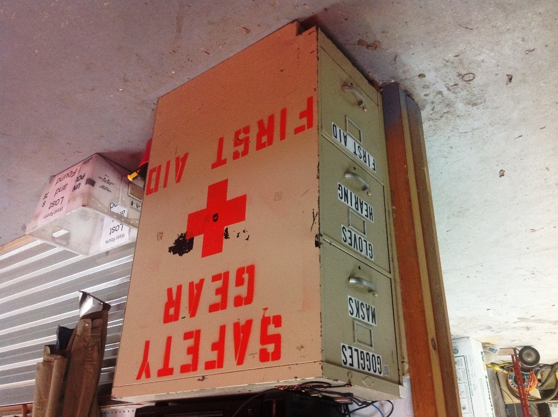
Behavior & Attitude
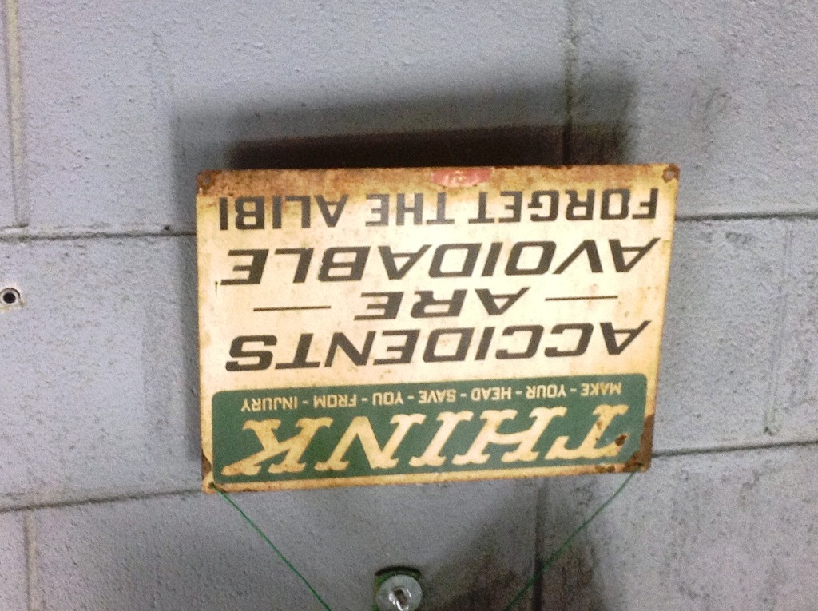
Behavior & Attitude
- Be aware of your environment
- Ask for help, get training
- Understand the hazards
- Slow down
- Store hazardous materials safely
- Clean areas are safer to work in
- Avoid injuries to yourself and others
- Avoid damaging equipment

Broken or Damaged Tools
- Stop use immediately
- Unplug and lock out
- Inform others
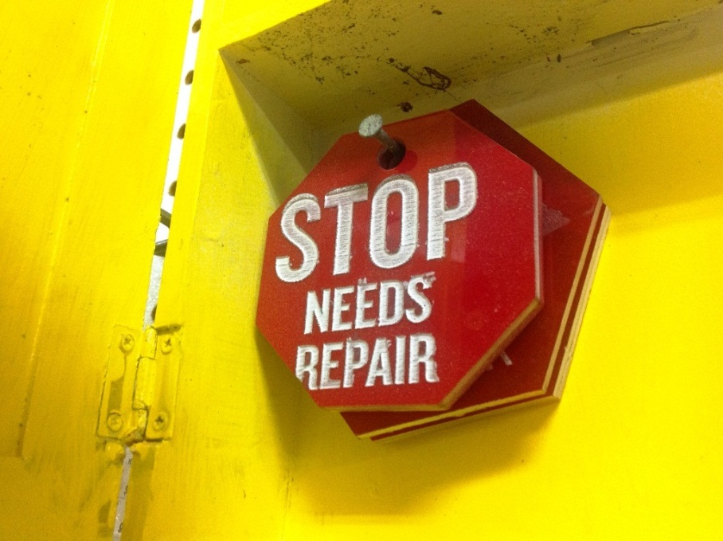
First Aid
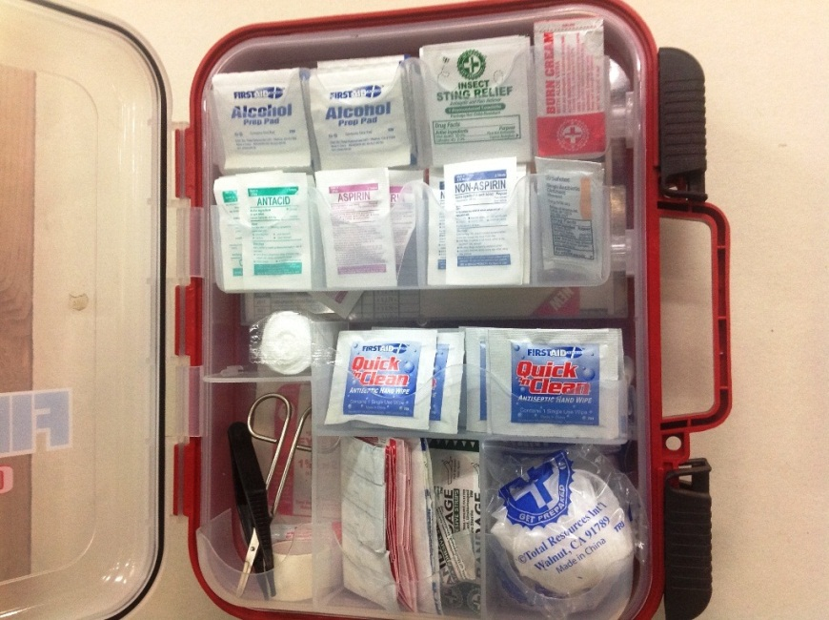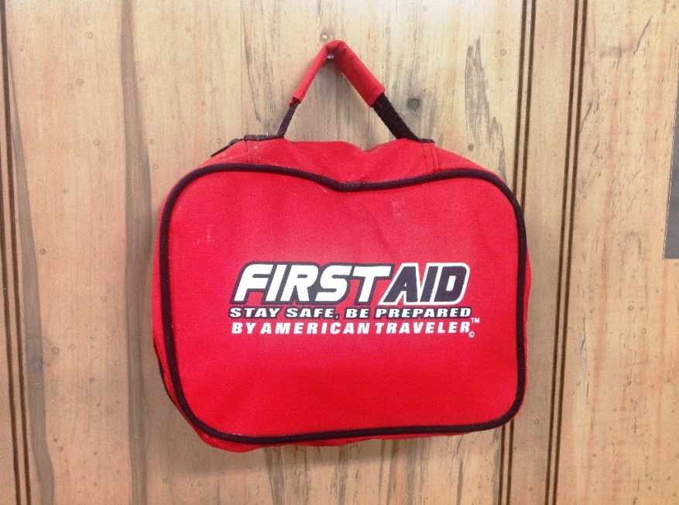

Reporting an injury

Fire Extinguishers
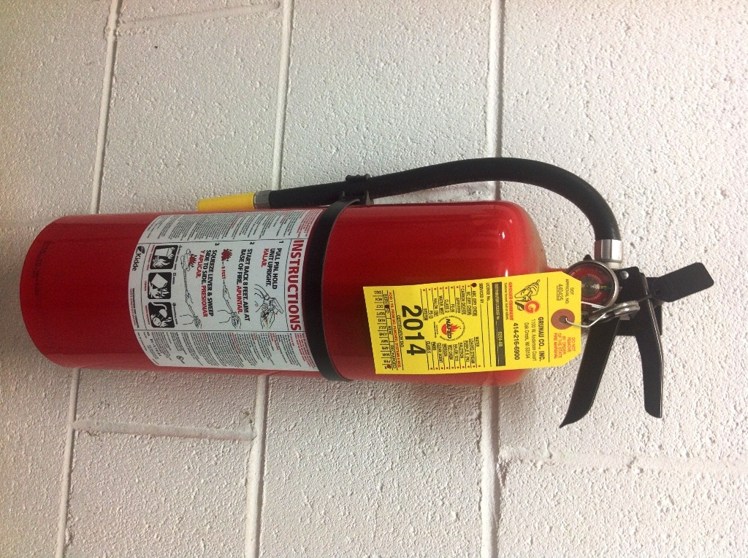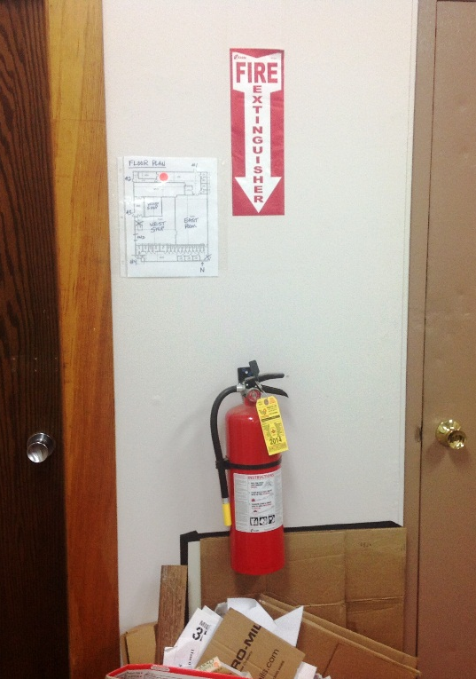

Fire Alarm Pull Stations
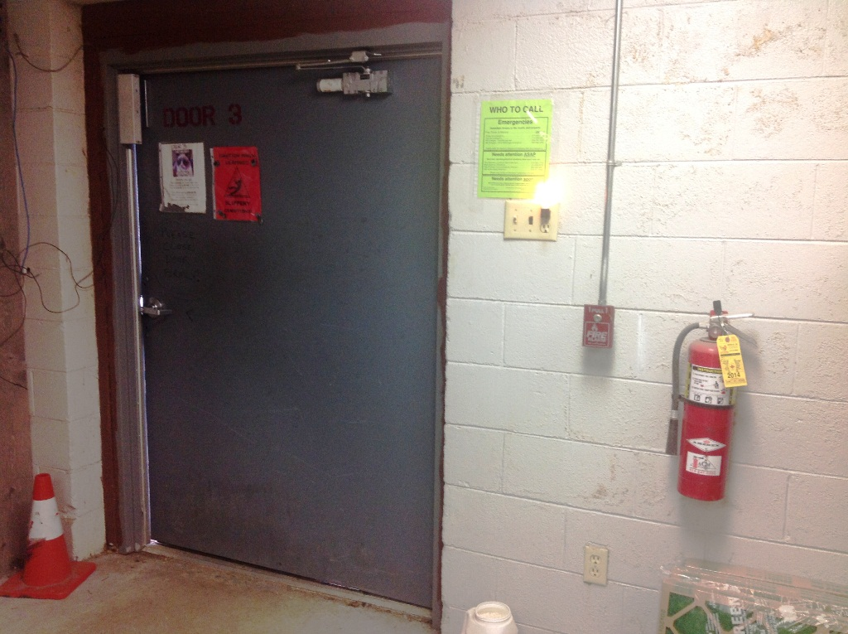

Emergencies
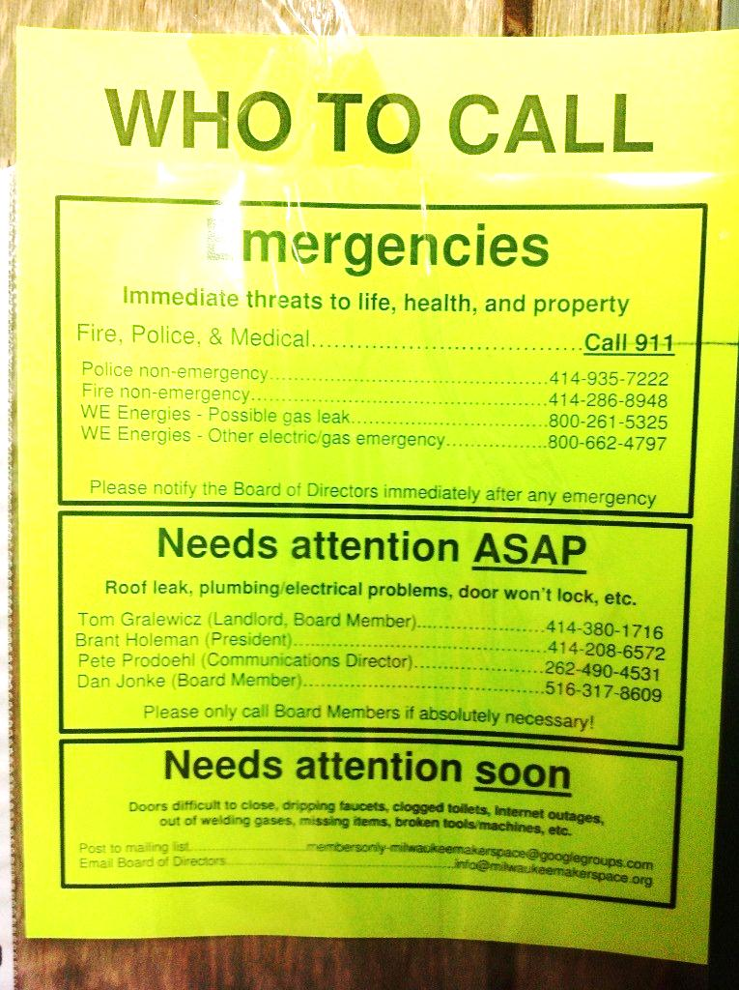

Cameras
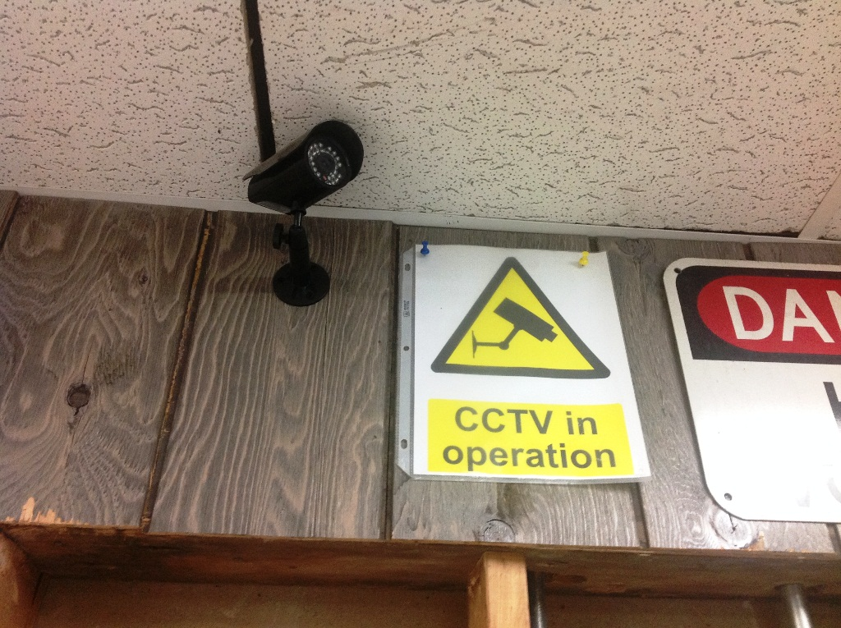

Meetings & Events

Regular Events
- Open Nights, Tuesdays & Thursdays
- Space Improvement Days
- Recurring Group Meetings

Special Events
- Gallery Nights
- Classes
- Special Tours
- Demonstrations

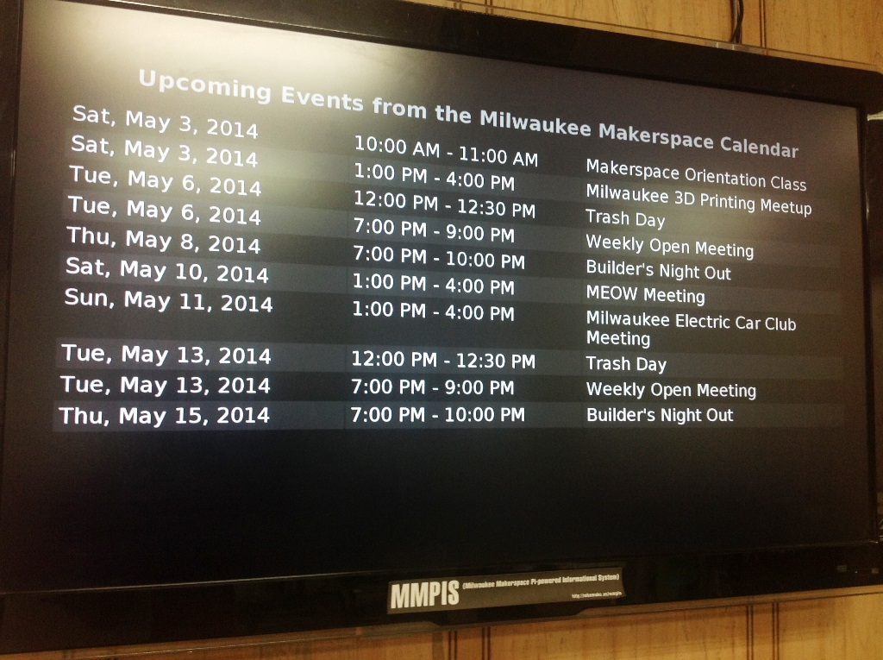

Social Media

Google Groups Mailing Lists
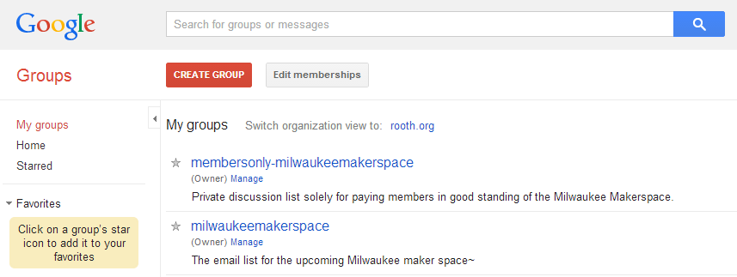

Blog and Wiki

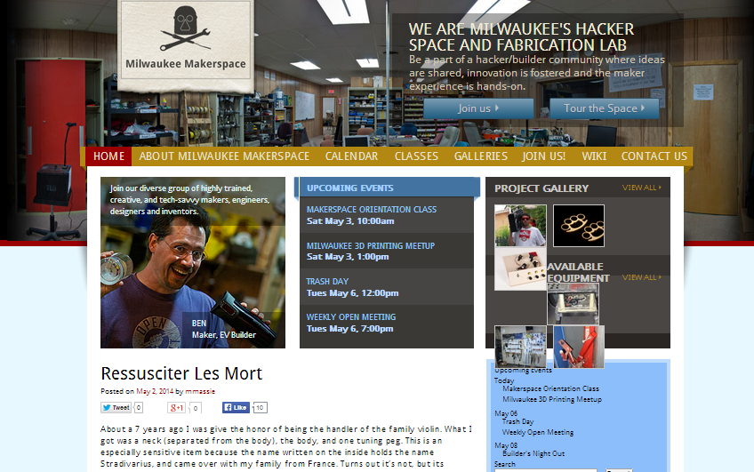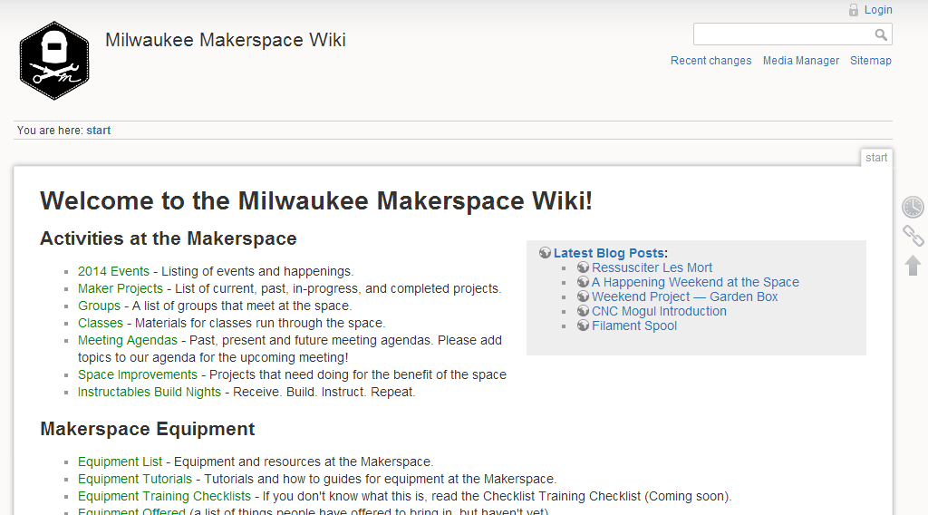

Other Media
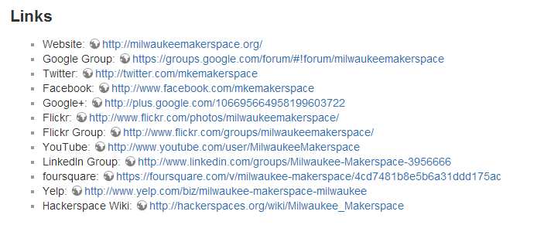

Our Culture

Who we are
Teachers, students, artists, writers, entrepreneurs, engineers, painters, welders, boat-builders, race car mechanics, chemists, hobbyists, tinkerers, do-it-yourselfers, hackers, craftsmen, inventors, and more

Our common interests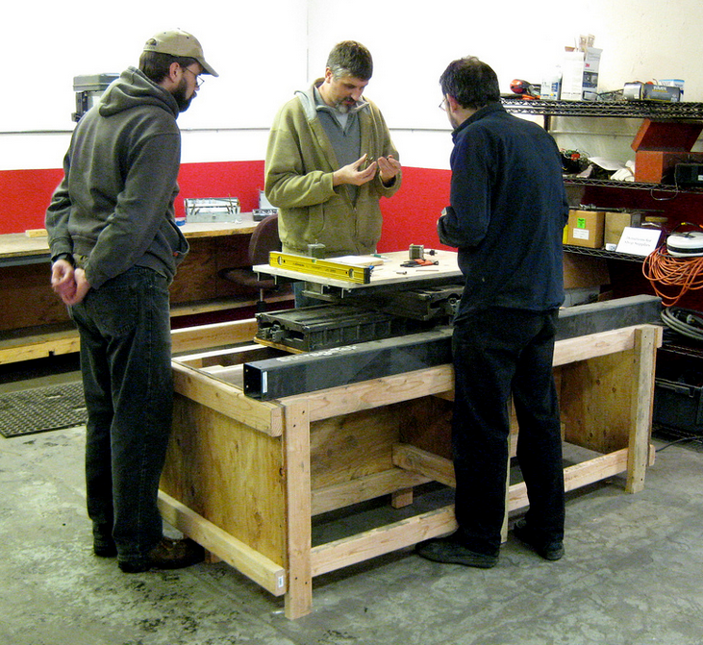 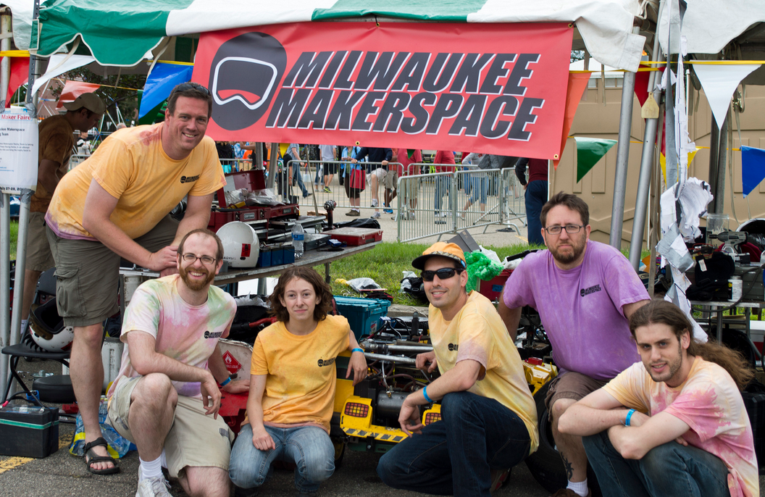 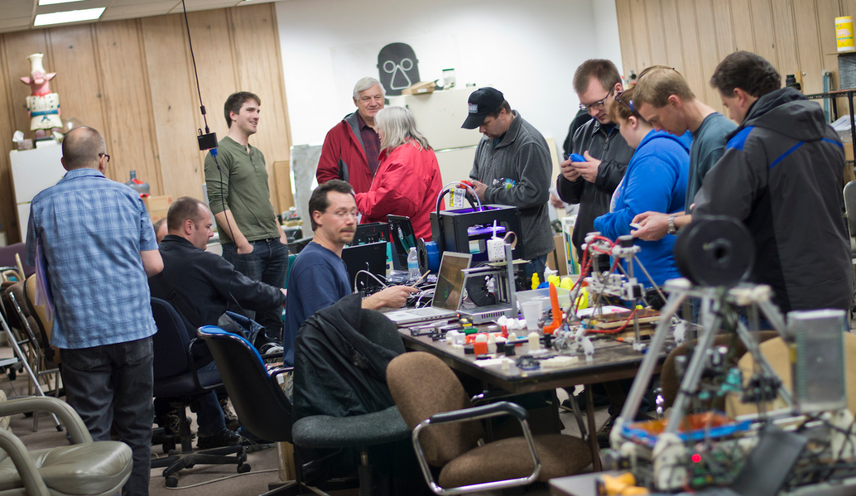 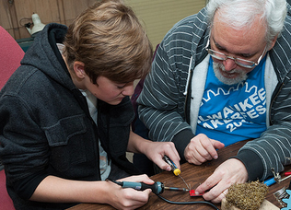

Glossary of Terms
- Do-ocracy
- Hacker
- Skill Collector
- Sweat Equity

Respect for yourself
Respect for others
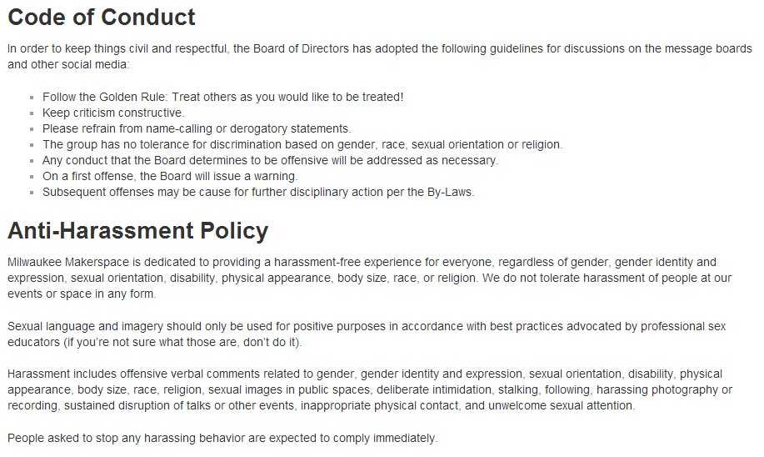

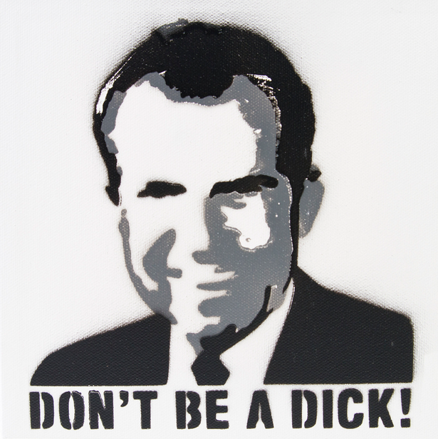

Thank you for your time!

